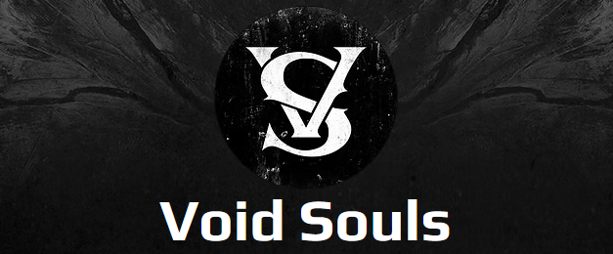

Gig History
(last updated 2026-06-30)

- April 5th, 2024 - Modern Love (Calgary, AB)
- May 31st, 2024 - Vern’s Pub (Calgary, AB)
- July 11th, 2024 - Burwood Music Festival (Calgary, AB)
- July 13th, 2024 - Border Crossing Pub (Calgary, AB)
- August 31st, 2024 - Rendezvous Pub (Edmonton, AB)
- September 27th, 2024 - Big Al’s Grill and Pub (Calgary, AB)
- November 7th, 2024 - Rockin 4 Dollars (Calgary, AB)
- November 8th, 2024 - Rendezvous Pub (Edmonton, AB)
- November 9th, 2024 - The Vat Pub (Red Deer, AB)
- November 13th, 2024 - The Blues Can (Calgary, AB)
- January 3rd, 2025 - Big Al’s Bar and Grill (Calgary, AB)
- January 23rd, 2025 - Vern’s Tavern (Calgary, AB)
- February 6th, 2025 - Band Mania @ Blues on Whyte (Edmonton, AB)
- February 7th 2025 - Langdon Firehouse (Langdon, AB)
- February 8th 2025 - The Vat Pub (Red Deer, AB)
- April 5th, 2025 - The Unicorn Stephen Ave (Calgary, AB)
- May 2nd, 2025 - BIg Al’s Bar and Grill (Calgary, AB)
- July 19th, 2025 - The Unicorn Stephen Ave (Calgary, AB)
- August 2nd, 2025 - Wright Wranch Music Festival (Eckville, AB)
- August 29th, 2025 - Waynestock Music Festival (Wayne, AB)
- October 4th, 2025 - The Unicorn Stephen Ave (Calgary, AB)
- December 3rd, 2025 - Ship & Anchor (Calgary, AB)
- February 4th, 2026 - The Blues Can (Calgary, AB)
- February 6th, 2026 - The Palomino (Calgary, AB)
- February 12th, 2026 - Rockin 4 Dollars (Calgary, AB)
- February 21st, 2026 - Chromosome Showcase Room (Edmonton, AB)
- February 28th, 2026 - Hitman’s Bar (Calgary, AB)
- April 16th, 2026 - Rockin 4 Dollars (Calgary, AB)
- April 25th, 2026 - The Unicorn Stephen Ave (Calgary, AB)
- May 20th, 2026 - The Blues Can (Calgary, AB)
- May 23rd, 2026 - Owl Acoustic Lounge (Lethbridge, AB)
- June 5th, 2026 - The King Eddy (Calgary, AB)
- June 26th, 2026 - Big Al’s Bar and Grill (Calgary, AB)
- June 28th, 2026 - Langdon Firehouse (Langdon, AB)

